

V 1.0
May 2026
XStep Design Specification
SMPL: Conditioned Medium Hold Times

Table of Contents
1 Purpose 3
2 Overview 3
3 Reasons for developing 4
4 Authorization 4
5 Assumptions/ Dependencies 4
6 Validation Checks 5
7 XStep Layout Design 6
8 Test Scenarios 6
9 Document References 7
10 Revision History 7

Purpose
This document outlines the functional and technical design, along with the configuration specifications for the XStep “SMPL: Conditioned Medium Hold Times”. The XStep is designed to capture sequential or alternating storage hold times across two different temperature bands. To minimize operator data entry errors and maintain GMP data integrity, the system implements the following automated relational logic:

Overview
The XStep contains several main input parameters:
- IV_HEADER - This can be changed in SiMPL MBR to display specific header text for the XStep
- IV_INSTR - This can be changed in SiMPL MBR to display a specific set of instructions for the XStep that will be displayed below the header

Dynamic Table Coupling: This step features two dynamically linked tables: Hold Start Time and Hold End Time. Adding a row via the + Add Row button in the Hold Start Time table automatically instantiates a corresponding row in the Hold End Time table.
Hold Start Time
The following fields are auto populated in the Xstep:
- “No.” - Output numeric field which auto-populates sequentially with each add table line. The first output value is “1”

The operator inputs the location:
- “Location” - Text Input

Alternating Temperature Defaulting: The Temp output string auto-populates and defaults for every second row item to map standard process movements.
- Row 1: Defaults to 2-8°C.
- Row 2: Defaults to R.T.
- Row 3+: Continues alternating sequentially if additional shifts are needed.
- “Temp” - Text output

The operator executes the “Get Start Time” button:
- Get Start Time - Function Button (The operator should only be able to press this button once)
The button is linked to the function module /SMPL/PPPI_FM_STR_PROC_STRT_TM to record the timestamp.
- “Start Time” - Output
- “Start Date” - Output

Hold End Time

The following fields are auto populated in the Xstep similar to the first table:
- “No.” - Output numeric field which auto-populates sequentially with each add table line. The first output value is “1”

The temp setting 2-8°C or R.T auto-populates and defaults for every second row item.
- “Temp” - Text output

The operator executes the “Get End Time” button:
- Get Start Time - Function Button (The operator should only be able to press this button once)
The button is linked to the function module /SMPL/PPPI_FM_GET_PROC_STRT_TM to record the timestamp.
- “End Time” - Output
- “End Date” - Output

The Hold Time Duration is calculated by subtracting the start time from the end time.
- “Hold Time Duration” - Output (/SMPL/PPPI_FM_CLEAR_PROC_TM)

The End Time and Date of the first row with the Temp of 2-8°C should auto-populate as the Start Time in the Start Time and Date fields of the second row labeled as 2-8°C in the Hold Start Time table.

The operator adds a row to record a second hold time duration.

The operator signs the Performed By field
- “Performed By” - Input

The following fields are auto-populated due to calculation of total hold time per separate Temp label:
- “Total R.T. Hold Time” - Time Output (hour and minutes) - the sum of the total End Times for every entry for the line item with a defaulted Time value of R.T.
- “Total 2-8°C Hold Time” - Time Output (hour and minutes) - the sum of the total End Times for every entry for the line item with a defaulted Time value of 2-8°C .
- “Total Combined Hold Time” - Time Output (hour and minutes) - the sum of the above two values

All three of the above hold time values require validation with the requirement of a supervisor signature if a specific time has been exceeded per single total time recording. These threshold times will be authored from MBR per part number.

Functional Design
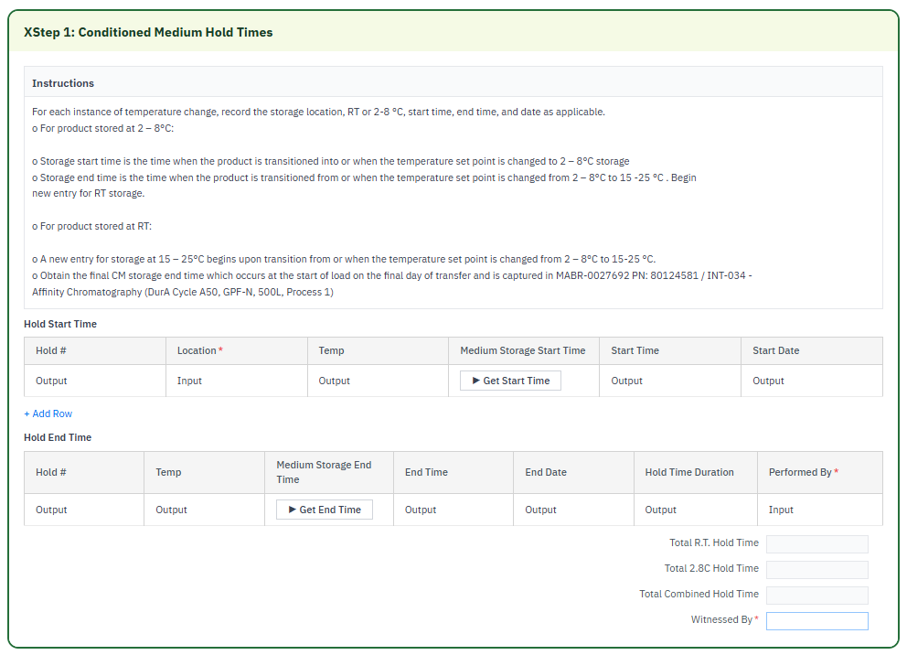

Reasons for developing
The development of this automated XStep is driven by the need to eliminate the compliance risks, calculation errors, and data entry burdens associated with manually executing the post-harvest hold time table. By automating data entry, the system eliminates human arithmetic errors during long, multi-day storage holds and systematically enforces complex inter-row dependencies by automatically propagating a row's end timestamp as the next row's start timestamp.

Authorization
The Signature Strategies SS000201 - SiMPL Done By and SS000202 - SiMPL Checked By are created and assigned to the Authorization Groups AGDS0001 PI step Done By SS and AGDS0002 PI step Checked By SS. This ensures that at least two users are required to successfully sign off the process step. The first user signs off in the Performed By field and a second user signs the Witnessed By field.

Assumptions/ Dependencies
 | Assumption
1 | User signing signature fields is an approved user in the system with the correct access configuration
2 | Master Data has been set up correctly
3 | The function modules are available and return the correct system time.
4 | The function module can successfully pull the data into the output fields
5 | The Get Start Time and Get End Time buttons freeze instantly upon receiving an initial system timestamp to prevent accidental recalculations.

Validation Checks
Error Handling
Error | Action
User Signature rejected due to an incorrect username or password | User accepts error message and re-enter the correct username and password
Mandatory field data not captured | A validation error is displayed - capture mandatory fields.
Value outside of the tolerance range is accepted. | Verify if tolerance ranges have been correctly authored in SiMPL MBR.

XStep Layout Design
*EBR screenshot wil be added once development and testing have been completed.

Configuration Specification
N/A

Test Scenarios
# | Scenario | Expected Result | Actual Result | Pass/ Fail
1 | Create and Release a Process Order with the pre-configured SiMPL Master Recipe and the relevant Production Version | Process Order created and Released containing SMPL: Solution Summary - Data Recording | Process Order created and Released containing SMPL: Solution Summary - Data Recording
2 | Open the EBR, and navigate to SMPL: Conditioned Medium Hold Times | The EBR for the selected Process Order and Control Recipe opens successfully without any errors and the SMPL: Conditioned Medium Hold Times | The EBR for the selected Process Order and Control Recipe opens successfully without any errors and the SMPL: Conditioned Medium Hold Times
3 | The operator inputs the location | Text value accepted. | Text value accepted.
4 | The operator executes the Get Start Time Button to get the system time | System time and date correctly displayed | System time and date correctly displayed
5 | The operator executes the Get End Time Button to get the system time | System time and date correctly displayed | System time and date correctly displayed
6 | The operator verifies that the Hold Time Duration is correct. | Hold Time Duration is correct | Hold Time Duration is correct
7 | The operator adds an additional table row in the first table | A second row is automatically populated in the second table | A second row is automatically populated in the second table
8 | The operator verifies that the Temp output for the first row across both tables displays 2-8°C and that the second row across both tables display R.T. | Output values correct | Output values correct
9 | The operator verifies that the end time of the first row auto-populates in the start time fields for the second row. | Output values correct | Output values correct
10 | Enter a username in the “Performed By” field then enter the password in the pop-up window. | Signature is accepted | Signature is accepted
11 | The operator verifies that the total R.T time is calculated correctly. | Calculation correct | Calculation correct
12 | The operator verifies that the total 2-8°C time is calculated correctly. | Calculation correct | Calculation correct
13 | The operator verifies that the total combined hold time is calculated correctly. | Calculation correct | Calculation correct
14 | The operator verified that a deviation popup occurs which requires a supervisor signature when any of the total times exceed the threshold that was authored from MBR | Validation correct | Validation correct
15 | Enter a username in the “Witnessed By” field then enter the password in the pop-up window. | Signature is accepted | Signature is accepted

Document References
Reference No. | Document Title
Number used in superscript for reference | Full name of referenced document
1 | SiMPL Functional Guide: Universal Concepts

Revision History
Version No. | Description | Author | Date
1.1 | Initial Document (Functional requirements and Technical specification) | Frieda van der Merwe | 21-05-2026

